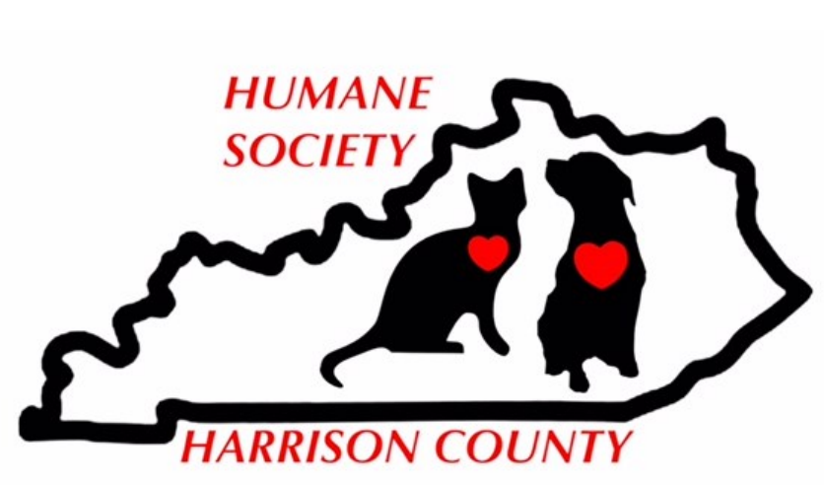
P.O. Box 861
Cynthiana, KY 41031
859.556.0071
Spay/Neuter Program Assistance Application
The Humane Society of Harrison County, a non-profit organization, promotes humane care of all animals in Harrison County with an emphasis on our Spay/Neuter Program by funding monthly spay/neuter surgeries for pets of Harrison County residents only

Name: _________________________________________________________________________________
Home Address: ________________________________ Mailing Address: _____________________________
City: ______________________________ Zip Code: ____________ County: _________________________
Phone No. _______________________________ Email: _________________________________________

Pet Information: This application is for one pet.
Cat/Dog Name Weight Sex Age Breed Description
________ __________________ _______ _____ _____ _______________________________

Note: The Humane Society of Harrison County limits 1 surgery per household per month and
2 per calendar year

Donations of any amount are accepted to help support our Spay/Neuter Program which depends on community contributions to ensure our Program can continue. Donations also help reduce our cost of your pet’s surgery which is paid in full by the Humane Society of Harrison County. I would like to donate $________ to the Humane Society of Harrison County Spay/Neuter Program. Please include your donation with this application. Make checks payable to “Humane Society of Harrison County”.

I agree the above information is true and correct to the best of my knowledge, I agree that any and all pets reside at my home address and are owned by me. I agree the Humane Society of Harrison County and its volunteers have no responsibility or liability for any injuries to the above animals caused directly or indirectly by participation in the Spay/Neuter Program. I agree to this waiver of liability.
Signature of Pet Owner: _____________________________________________ Date: _______________

Applications are reviewed for approval on the second Tuesday of each month based on availability of funds. If your pet is approved for our Spay/Neuter Program, you will be mailed a certificate which includes all information to schedule the surgery including the expiration date. All surgeries must be completed within 45 days of approval.
Please mail completed application to:
Humane Society of Harrison County at P.O. Box 861, Cynthiana, KY 41031

11/12/19
www.hshc.us facebook.com/HSHCKY

